Parabola Construction
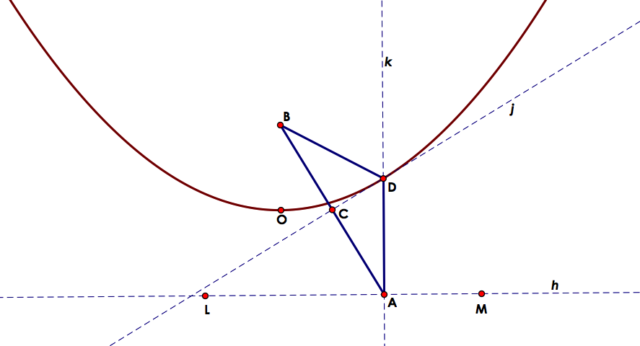
Create a directrix by forming a line h through two points (L and M). Choose some point A on h and another point B that does not lie on the line. Generate a line segment from B to A and mark the midpoint of this segment as point C. Next, find the perpendicular bisector j of line AB through the midpoint C. Construct a line perpendicular to h through point A. The lines j and k intersect at a point D. Lastly, find the locus of D as a function of A. The locus is a parabola with vertex O and the focus B.

Hyperbola Construction
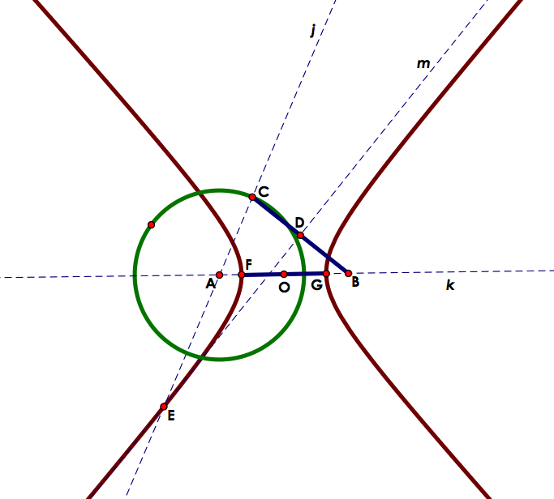

Start by constructing a circle with a center A. From there choose a point B outside of the circle. Construct a line k through points A and B. Then choose a point C on the circle. Construct a line j through points A and C. Make a line segment from C to B and mark the midpoint of this segment as point D. Find the perpendicular bisector m of line segment BC through D. The lines m and j intersect at point E. Finally; determine the locus of point E as a function of point C. This locus is a hyperbola with center O (which is found by taking the midpoint of the line segment A and B), foci A and B, and vertices F and G (which is found through the intersection of the locus and line k).

Ellipse Construction
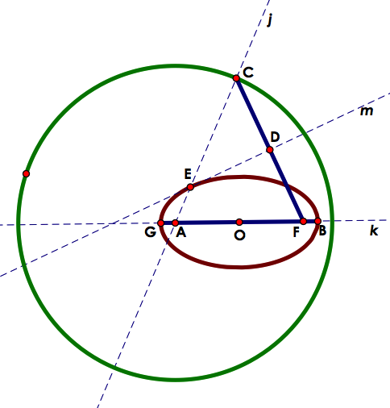

Start by constructing a circle with a center A. From there choose a point F inside of the circle. Construct a line k through points A and F. Then choose a point C on the circle. Construct a line j through points A and C. Make a line segment from C to F and mark the midpoint of this segment as point D. Find the perpendicular bisector m of line segment CF through D. The lines m and j intersect at point E. Finally; determine the locus of point E as a function of point C. This locus is an ellipse with center O (which is the midpoint of the line segment AF), foci A and F, and vertices G and B that lie on the semi-major axis k.

Circle Construction
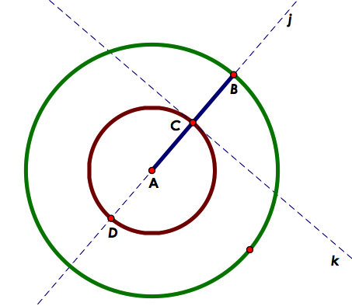

Start by constructing a circle with a center A. From there choose a point inside of the circle. However, since the center of the circle and the foci are the same, the point chosen inside will be the center of the circle. Next, select a point B on the circle. Construct a line j through points A and B. Make a line segment from B to A and mark the midpoint of this segment as point C. Find the perpendicular bisector k of line segment AB through C. The lines k and j intersect at point C. Lastly; determine the locus of point C as a function of point B. The locus is a circle with center A, and vertices D and C that lie on the semi-major axis j. (Note the similarities between the circle construction and that of the ellipse.)

